Test Case: tc001_SPX_Dev5_Crear_Solicitud_Articulo_Almacen
Step 1 - Enter username and password and click to button Enter : Credentials Entered
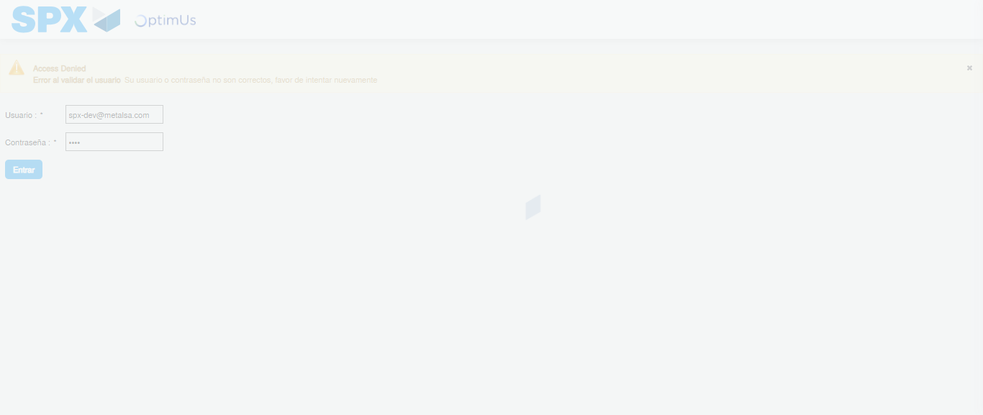Image file-name: QC_Testing-tc001_SPX_Dev5_Crear_Solicitud_Articulo_Almacen-1787865045866

Step 2 - Select to UEN and Access to Request for a New Inventory Item : UEN Correctly selected and Correct access
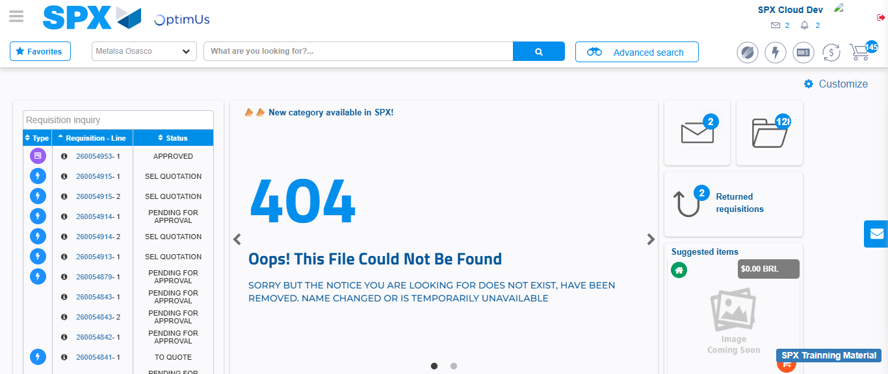Image file-name: QC_Testing-tc001_SPX_Dev5_Crear_Solicitud_Articulo_Almacen-1787865072312

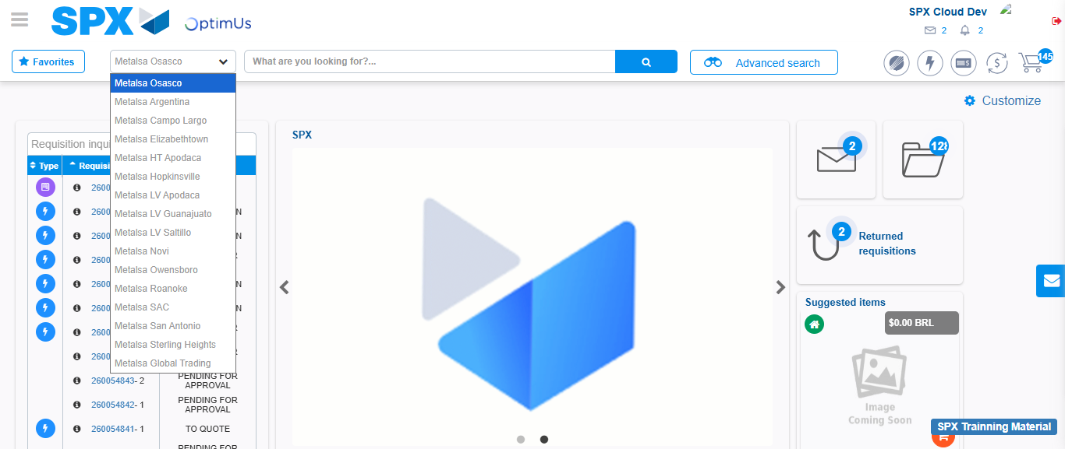Image file-name: QC_Testing-tc001_SPX_Dev5_Crear_Solicitud_Articulo_Almacen-1787865073077

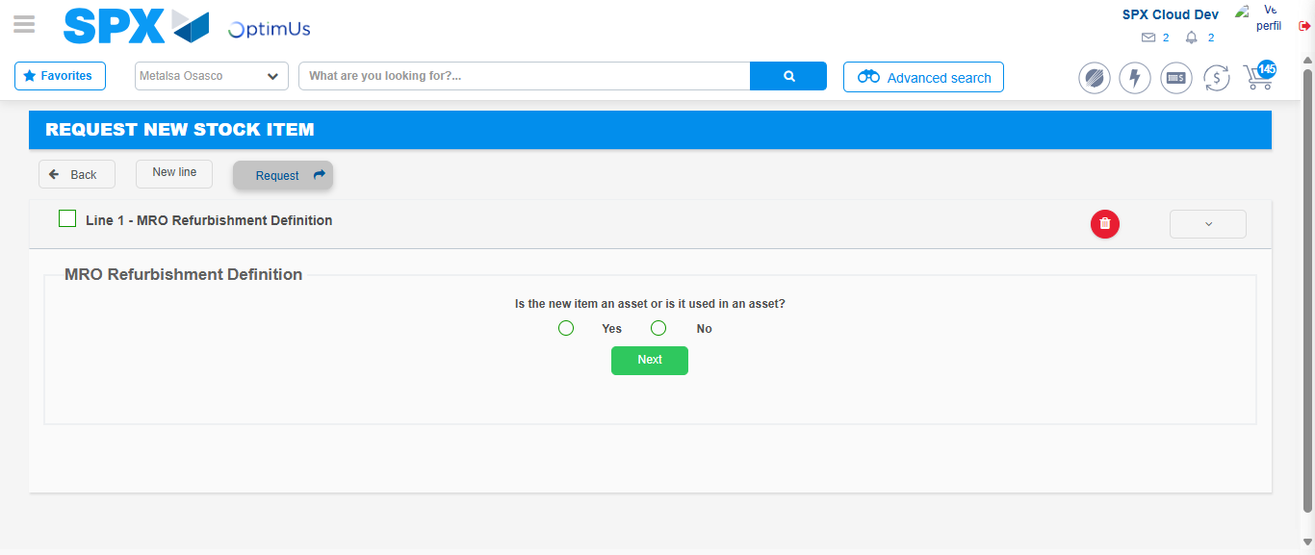Image file-name: QC_Testing-tc001_SPX_Dev5_Crear_Solicitud_Articulo_Almacen-1787865126512

Step 3 - Select options first section : Options seleted correctly
Image file-name: QC_Testing-tc001_SPX_Dev5_Crear_Solicitud_Articulo_Almacen-1787865126822

Image file-name: QC_Testing-tc001_SPX_Dev5_Crear_Solicitud_Articulo_Almacen-1787865127028

Step 4 - Select options at Screen: Options seleted correctly
Image file-name: QC_Testing-tc001_SPX_Dev5_Crear_Solicitud_Articulo_Almacen-1787865126822

Image file-name: QC_Testing-tc001_SPX_Dev5_Crear_Solicitud_Articulo_Almacen-1787865127028

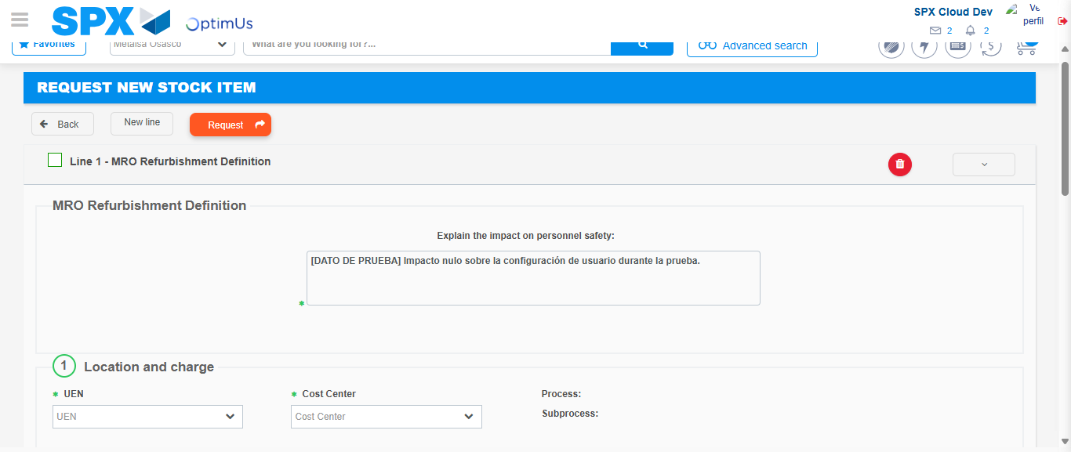Image file-name: QC_Testing-tc001_SPX_Dev5_Crear_Solicitud_Articulo_Almacen-1787865133516

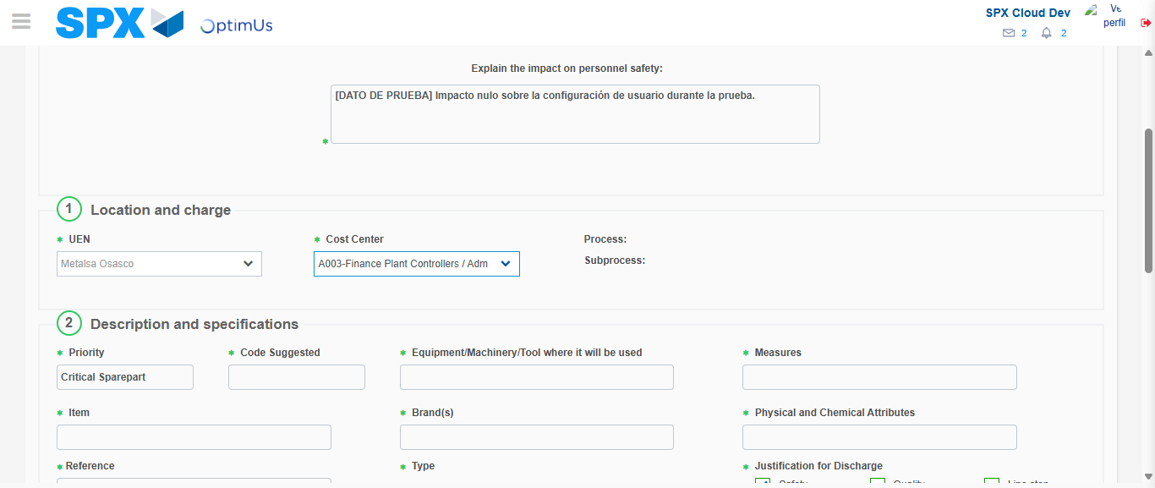Image file-name: QC_Testing-tc001_SPX_Dev5_Crear_Solicitud_Articulo_Almacen-1787865135898

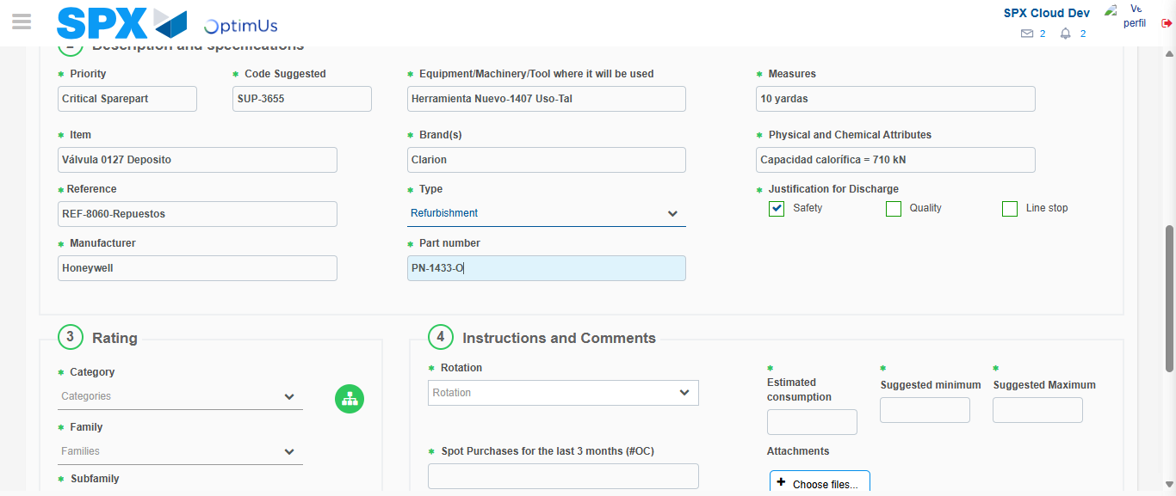Image file-name: QC_Testing-tc001_SPX_Dev5_Crear_Solicitud_Articulo_Almacen-1787865137747

Step 7 - Return to Main Page SPX : Return to Main Page SPX
Image file-name: QC_Testing-tc001_SPX_Dev5_Crear_Solicitud_Articulo_Almacen-1787865072312

Image file-name: QC_Testing-tc001_SPX_Dev5_Crear_Solicitud_Articulo_Almacen-1787865073077

Image file-name: QC_Testing-tc001_SPX_Dev5_Crear_Solicitud_Articulo_Almacen-1787865126512

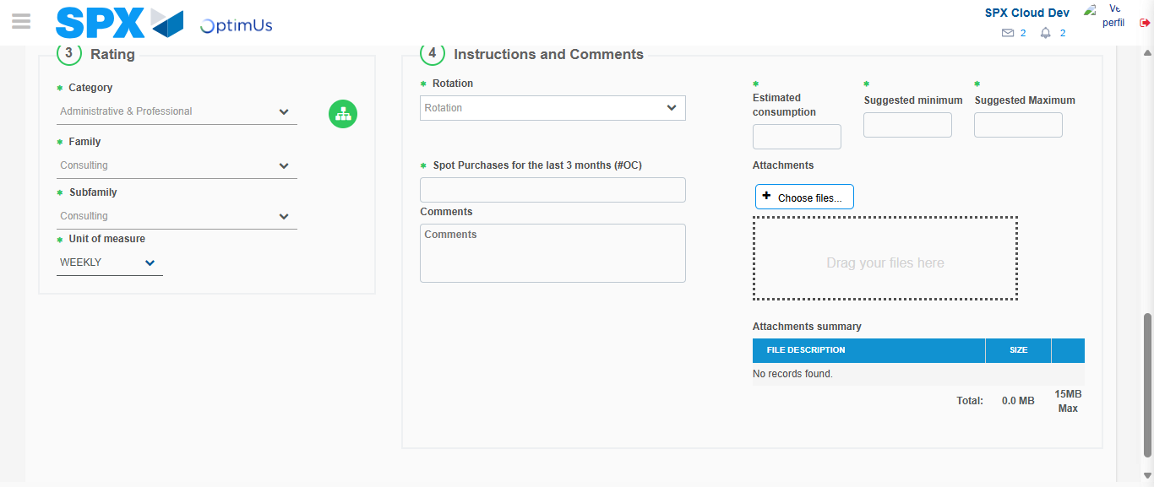Image file-name: QC_Testing-tc001_SPX_Dev5_Crear_Solicitud_Articulo_Almacen-1787865144960

Image file-name: QC_Testing-tc001_SPX_Dev5_Crear_Solicitud_Articulo_Almacen-1787865145202

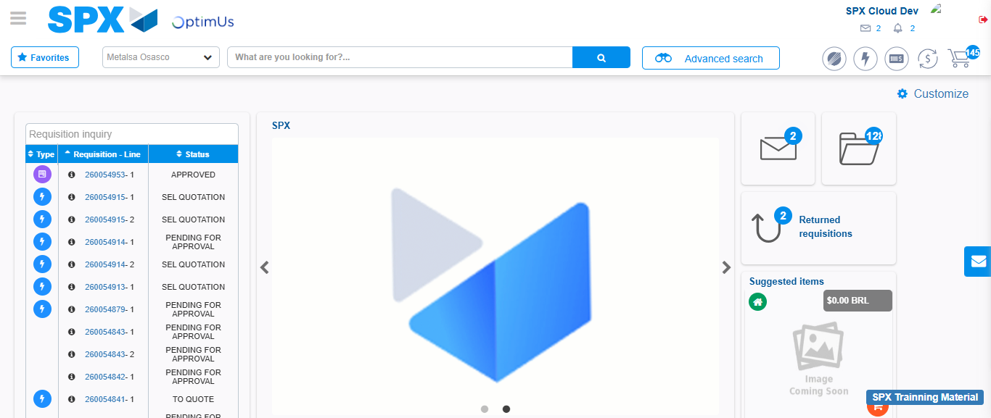Image file-name: QC_Testing-tc001_SPX_Dev5_Crear_Solicitud_Articulo_Almacen-1787865166455

Step 8 - Log Out : Log Out SPX
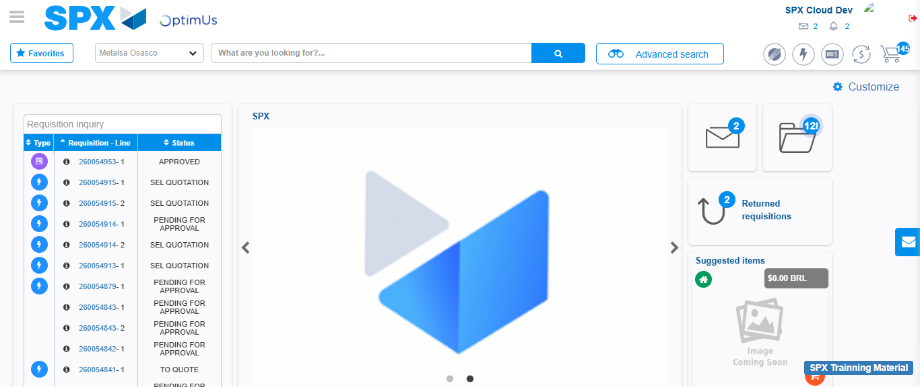Image file-name: QC_Testing-tc001_SPX_Dev5_Crear_Solicitud_Articulo_Almacen-1787865166812

